Module 3 Summary – Jacob booth 221530207

Response to feedback
Regarding feedback from module 2, I’ve cleaned up my working out for correct matrix notation, after this module I’ll try to strictly use ( ) so I don’t confuse it with | | in determinants. Regarding the summary, I’ve adopted a new approach that prioritises the overall picture, instead of addressing each concept individually, I’ve really leaned into identifying the ties for each definition/theorem. I think overall I’m starting to get the idea, but still wondering if I’ve regurgitated/rephrased too much in this one.
Module Learning Objectives
I certify that I achieved the following learning objectives for the module:
1) Apply the inversion algorithm to find a matrix inverse
2) Identify and work with elementary matrices
3) Work with matrices algebraically and identify correspondence between key linear mappings and their matrices
Key Definitions and Theorems
Matrix Inverses
Textbook Ref | Theorem/Definition statement | Learning Notes
Definition 2.11  Matrix Inverse | If A is a square matrix, a matrix B is called an inverse of A if and only if  AB = I and BA = I  A matrix A that has an inverse is called an invertible matrix and denoted A⁻¹ | DIFFERENT FROM THE NEGATION, remember that this isn’t the negative matrix but its inversion
Theorem 2.4.1 Uniqueness of inverse | If B and C are both inverses of A, then B = C. | Think about the rules with matrix multiplication, sometimes C might not be known but must still be identical if it returns the same result as B, there’s a single inverse for every invertible matrix
Matrix Inversion Algorithm | If A is an invertible (square) matrix, there exists a sequence of elementary row operations that carry  A to the identity matrix I of the same size, written A→I. This same series of row operations  carries I to A⁻¹; that is, I →A⁻¹. The algorithm can be summarized as follows:  [ A I ] → [ I A⁻¹]  where the row operations on A and I are carried out simultaneously. | Note that the inverse doesn’t always exist, and REMEMBER that the identity matrix is the matrix representation of scalar 1, it leaves it unchanged (replacing the 1s with any real x will be that scalar’s matrix representation, I assume)
Theorem 2.4.4 Inverse properties | All the following matrices are square matrices of the same size.  1. I is invertible and I⁻¹ = I.  2. If A is invertible, so is A⁻¹, and (A⁻¹)⁻¹ = A.  3. If A and B are invertible, so is AB, and  (AB)⁻¹ = B⁻¹A⁻¹.  4. If A₁, A₂, . . . , A_{k} are all invertible, so is their product A₁A₂ ···A_{k}, and  5. If A is invertible, so is A^{k} for any k ≥ 1, and  (A^{k})⁻¹ = (A⁻¹)^{k}.  6. If A is invertible and a  0 is a number, then aA is invertible and  7. If A is invertible, so is its transpose A^{T}, and  (A^{T} )⁻¹ = (A⁻¹)^{T}. | Note the swapping behaviour in the definition, applying inverses to the matrices inverts their corresponding multiplication order.  If multiplying by the inverse returns “1” then it might be similar to multiplying the matrix by 1/A, or dividing A/A? Multiplying by the inverse seems to be the tool for this.
Theorem 2.4.5 Inverse Theorem | The following conditions are equivalent for an n×n matrix A:  1. A is invertible.  2. The homogeneous system Ax = 0 has only the trivial solution x = 0.  3. A can be carried to the identity matrix I_{n} by elementary row operations.  4. The system Ax = b has at least one solution x for every choice of column b.  5. There exists an n×n matrix C such that AC = I_{n}. | It needs to be square, no empty vars, and the corresponding matrix that reduces it to I is the inverse. NOTE an identity matrix is essentially in RREF without the constants, it represents 1 for each x in x1, …, xn.
Elementary Matrices
Textbook Ref | Theorem/Definition statement | Notes
Definition 2.12 Elementary Matrices | An n×n matrix E is called an elementary matrix if it can be obtained from the identity matrix I_{n} by a single elementary row operation (called the operation corresponding to E). We say that E is of type I, II, or III if the operation is of that type:  - Interchanging two rows  - Multiplying one row by a non-zero number  - Adding a multiple of one row to a different row | Elementary row operations in matrix form, convenient application
Theorem 2.5.4  Uniqueness of reduced row-echelon form | If a matrix A is carried to reduced row-echelon matrices R and S by row operations, then R = S. | If you apply row operations to a matrix and get two different reduced forms, those forms must be equal, no matter how you simplify the matrix, it will return the same result.
Linear Transformations
Textbook Ref | Theorem/Definition statement | Notes
Definition 2.13 | A transformation T :   ℝ^{n} → ℝ^{m} is called a linear transformation if it satisfies the following two conditions for all vectors x and y in ℝ^{n} and all scalars a:  T1 T(x+y) = T(x)+T(y)  T2 T(ax) = aT(x) | Bare in mind the behaviour of linear transformations is essentially matrix multiplication, I’ll lean more into this idea of a T() function call passing matrix as a param, this describes how the arithmetic can be reordered.
Theorem 2.6.1 Linearity Theorem | If T :   ℝ^{n} → ℝ^{m} is a linear transformation, then for each k = 1, 2, . . .  T(a₁x₁+a₂x₂+···+a_{k}x_{k}) =a₁T(x₁)+a₂T(x₂)+···+a_{k}T(x_{k})  for all scalars a_{i} and all vectors x_{i} in ℝ^{n}. | The effects of multiplying with linearity, scalar multiplication can be applied after a transformation and resolve the same.  NOTE continue to actively recognise individual vectors which make up the matrix
Theorem 2.6.4 Rotations | The rotation R : ℝ² → ℝ² is the linear transformation with matrix | Think about rotation tools in graphic design software, special matrices like this make vector graphics easily editable
Theorem 2.6.5 Reflections | Let Q_{m} denote a reflection transformation with respect to the line y = mx. Then Q_{m} : ℝ² → ℝ² is a linear transformation with matrix | Another graphic design concept, this allows us to easily create mirrored duplicates along an axis/plane
Theorem 2.6.6 Projection | Let P_{m} be projection on the line y = mx. Then P_{m} : ℝ² → ℝ² is a linear transformation with matrix | This lies at the core of pre-ray-traced graphics and screen-space rendering, determining how 3D objects should appear on a 2D screen from different angles

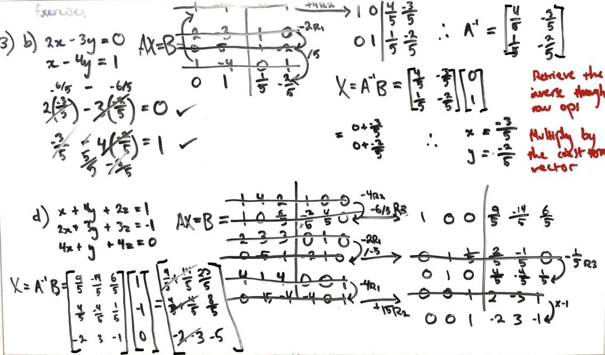
Module 3
Module 3 expands matrix multiplication and RREF form to sequential operations. Here we unpack the concepts necessary for linearly transforming a system through small, elementary operations, and how their products can be expressed through transformations. The inverse is also introduced as a means for undoing these transformations, if possible.
3.1 Matrix Inverses
Essentially “undoing” the effects of a matrix, inverse matrices A⁻¹ return the identity I in multiplication of A * A⁻¹ . Not all matrices have inverses. If a change is induced by a matrix through multiplication, the inverse undoes the change induced by the original matrix.
Definition 2.11 Inverse Matrix
If multiplying a matrix A by matrix B yields the Identity, A has an inverse (B). Essentially, A⁻¹ resets matrix A. Since the Identity matrices are square, and A*A⁻¹ yields the n*n identity matrix I, the inverse must be square to preserve this structure. Invertible matrices are therefore square. This is clarified in Theorem 2.4.5, outlining all 5 constraints of n*n matrices according to inverse theorem (see 1: A is invertible).
Uniqueness of inverses
As per Definition 2.11, Only a single inverse exists for an invertible matrix. Undoing the effects of a matrix has to be performed in the exact reverse of the original, there’s no alternative equal way. Theorem 2.4.4 provides multiple ways this iterative logic can be reordered, extending to the behaviour of matrix products, where order is key. This goes both ways for inverting and undoing inversion.
Matrix Inversion Algorithm
Prepare an augmented matrix with A on the LHS and its corresponding I on the RHS
( A | I ), then perform elementary row ops on the whole thing to bring A to I. This will naturally bring I to A⁻¹, but only if an inverse exists for A.
If any rows in the resulting LHS contain only 0s, the rank of the n*n matrix is less than n, so there’s no inverse for A. This ties together inverse theorem and inverse properties (T2.4.5 and T2.4.4) to achieve sequential, reversible inversion.
Theorem 2.4.4 Inverse Properties
Multiplying invertible matrices yields an invertible matrix, and Inverting the inverse returns the original matrix. Inverting a matrix product inverts each in reversed order, i.e., (AB)⁻¹ = B⁻¹ A⁻¹. As per Definition 2.11, multiplication must be commutative in regards to I.
Theorem 2.4.5 Inverse Theorem
If the process of Matrix Inversion yields a row of all 0s then A has no inverse. The resulting I must have full rank, otherwise the corresponding A⁻¹ isn’t possible. Condition 3 largely governs whether the inverse algorithm is successful for a matrix (whether inverse can be found).
3.2 Elementary Matrices
An Elementary Matrix represents a single elementary row operation that can be performed on a corresponding n*n matrix. They’re obtained by performing a single row operation on the corresponding identity. This implies that all elementary matrices are square. They express individual row operations in matrix form, and can be applied through multiplication.
Definition 2.12
Performing any of the 3 elementary row ops on an I matrix yields an elementary matrix, which can be applied to another matrix A to perform that same row operation. Elementary matrices are naturally square, and by Theorem 2.4.5, invertible.
Theorem 2.5.4
A sequence of row operations can be represented as an elementary matrix product. Regardless of the specific operations, the resulting RREF will be equal. This directly implies Definition 2.12 and clarifies that different approaches will yield the same overall transformation when reducing A to RREF.
3.3 Linear Transformations
Transformations are changes induced by another matrix. This allows transitions of one matrix state to another, consistently and predictably, while the original system is preserved. Linear transformations scale the data linearly, preserving these properties and behaviours. These concepts are heavily used in 2D/3D animation/vector graphics.
Definition 2.13 LU Theorem
Square matrices can be broken down into simpler sub-parts for lower-left entries and upper-right entries, where lower triangular L and upper triangular U imply that A = LU. This implies transformational decomposition in matrix multiplication, using simpler sequential steps to target specific aspects and effects of a matrix.
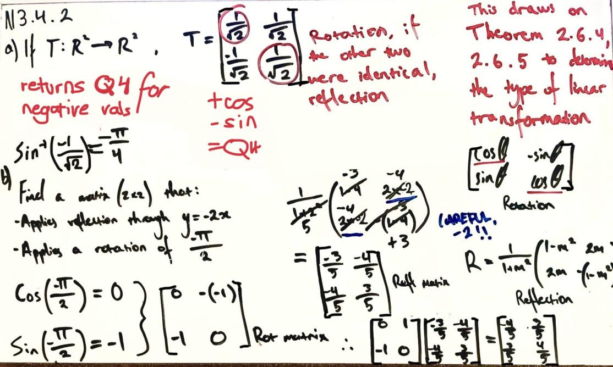
Theorem 2.6.1 Linearity Theorem
For a transformation to be considered linear:
- Vector addition and transformation reordering must yield the same result
- Vector scaling and transformation reordering must also return the same result
As per Definition 2.13, matrix composition can express the matrix for any linear transformation.
Theorem 2.6.4 Rotations
Vectors in 2D and 3D space can be rotated by multiplying them by a rotation matrix. Length is preserved while the vector turns around its origin by a specified angle. Rotations don’t distort the data, so the system structure is preserved.
Theorem 2.6.5 Reflections
Reflections flip a vector over a line or plane, resulting in a mirror image. Reflections preserve matrix length and all proportions in the mirrored result, so the structure is always preserved.
Theorem 2.6.6 Projection
Projections impose a vector straight down upon a line or plane, resulting in the closest point on the line/plane to the original vector. This flattens elements/points into simpler forms, like a shadow of a 3D object cast onto a 2D surface.
Determining whether a transformation represents a rotation, or reflection upon a line, can be verified by checking whether the e₁₁ and e₂₂ values are equal (rotation). If instead, the e₁₂ and e₂₁ elements are equal, it’s a reflection. Both Theorem 2.6.4 and 2.6.5 define the special matrices responsible for these transformations.
Theorem 2.6.4, 2.6.5, and 2.6.6 reflect constraints outlined in Theorem 2.4.5, by which any transformation that reduces the rank of matrix A, has no inverse. Theorem 2.6.1 expresses linear transformations as a composition of matrix multiplication (matrix A for each transformation T), and building from the compositional approach established in Definition 2.13, any linear transformation can be expressed as such.
Module 3 defines all the building blocks for expressing complex transformations as a composition of elementary linear operations. This goes beyond elimination and establishes tools for applying, reversing, and decomposing transformations. Where applicable, the inverse can effectively undo any linear transformation induced by the original matrix, which can be broken down into individual elementary operations describing the step-by-step linearity of a composition. This scopes row ops within elementary matrices, and their sequence within composition. Multiplying compositions yields more complex transformations, constructed of all the same elementary parts in the same hierarchy.

Reflecting on the content:
This module was a good point for tying together Modules 1, 2, and composition/transformations. I had a few problems getting my calculator configured for working in fractions for the trigonometry aspects, but the most important concepts were very intuitive to work with. I had to work with some rephrasing to really get my head around the composition annotations, but I feel more confident now that I’ve got 3 clear stages of progression. The hierarchy established in this module will help me scope the upcoming modules with better context now that these core building blocks are established. Overall, a very important module for using all module 1 and 2 concepts in context.

References
Summary and Notes
[1] D. Margalit and J. Rabinoff, “Matrix Transformations,” Interactive Linear Algebra, LibreTexts, [Online]. Available: https://math.libretexts.org/Bookshelves/Linear_Algebra/Interactive_Linear_Algebra_(Margalit_and_Rabinoff)/03%3A_Linear_Transformations_and_Matrix_Algebra/3.01%3A_Matrix_Transformations.
[Accessed: Jul. 30, 2025].
[2] D. Margalit and J. Rabinoff, “Matrix Inverses,” Interactive Linear Algebra, LibreTexts, [Online].
Available: https://math.libretexts.org/Bookshelves/Linear_Algebra/Interactive_Linear_Algebra_(Margalit_and_Rabinoff)/03%3A_Linear_Transformations_and_Matrix_Algebra/3.05%3A_Matrix_Inverses.
[Accessed: Jul. 30, 2025].
[3] A. Doerr and K. Levasseur, “Matrix Inversion,” Applied Discrete Structures, LibreTexts, [Online].
Available: https://math.libretexts.org/Bookshelves/Combinatorics_and_Discrete_Mathematics/Applied_Discrete_Structures_(Doerr_and_Levasseur)/12%3A_More_Matrix_Algebra/12.02%3A_Matrix_Inversion.
[Accessed: Jul. 30, 2025].
Calculations/Verification
[4] Apple Inc., “Calculator Infinity,” App Store. [Online].
Available: https://apps.apple.com/us/app/calculator/id458535809.

